Task 2: Security Mitigation & API Remediation Report

Course: D385 - Software Security and Testing

Student Name: Jani McCoy

Date: August 30, 2026

Section A: General Security Vulnerabilities

A1: Original Insecure Code (General Vulnerabilities)
- Vulnerability 1 Description (Hardcoded Flask Secret Key):

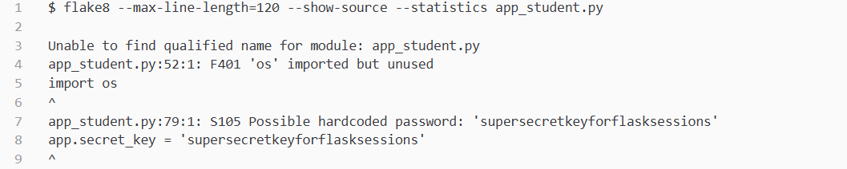
- Vulnerability 2 Description (Potential SQL Injection):

A2: Secure Replacement Code
- Secure Replacement 1 (Hardcoded Flask Secret Configuration):

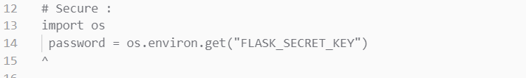
- Secure Replacement 2 (SQL Injection Guard):

A3: Disabled Original Code
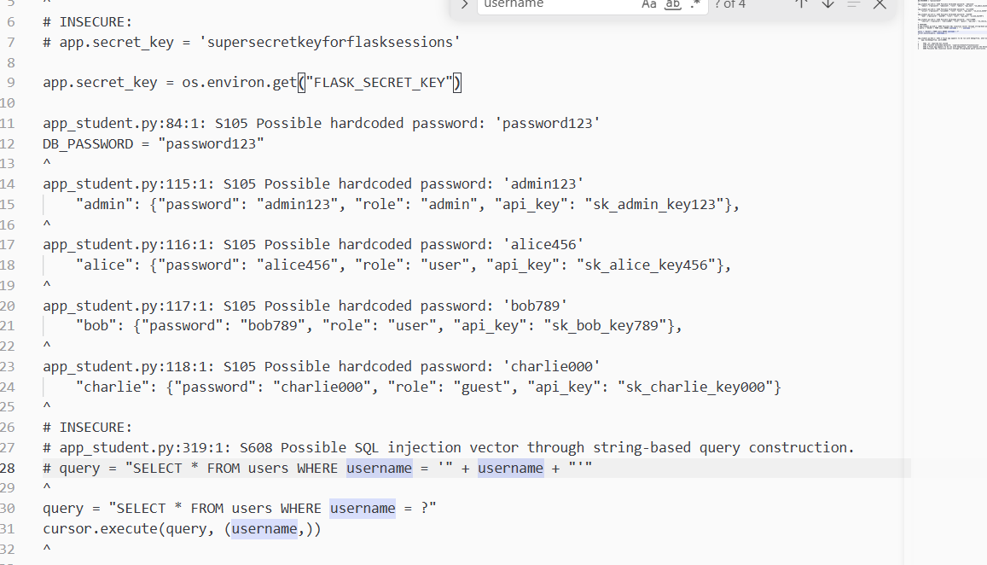

Section B: API Security Vulnerabilities

B1: Original Insecure API Code
- API Vulnerability 1 Description (Potential SQL injection vulnerability):

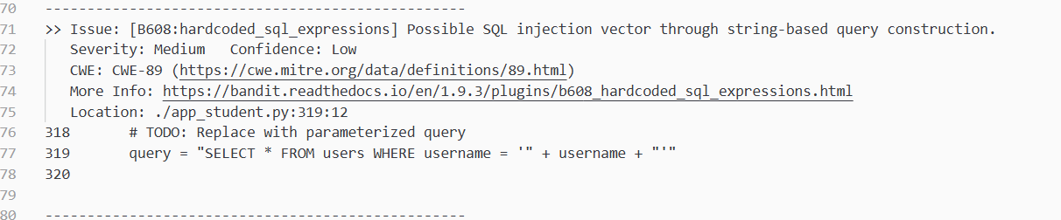
- API Vulnerability 2 Description (Flask-debug/ Arbitrary Code vulnerability):
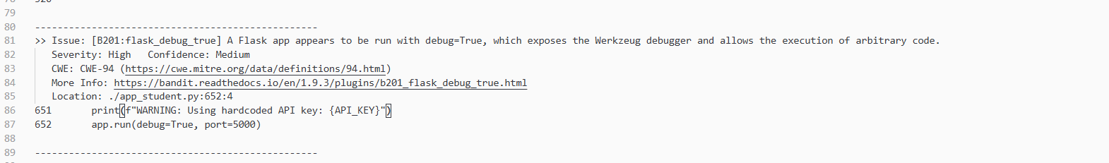

B2: Secure API Replacement Code
- Secure Replacement 1 (SQL Injection vulnerability patched):

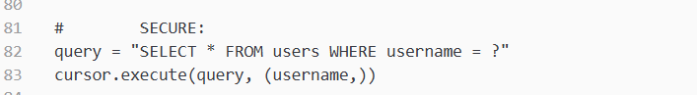

- Secure Replacement 2 (Flask debug / Hardcoded API key patch):
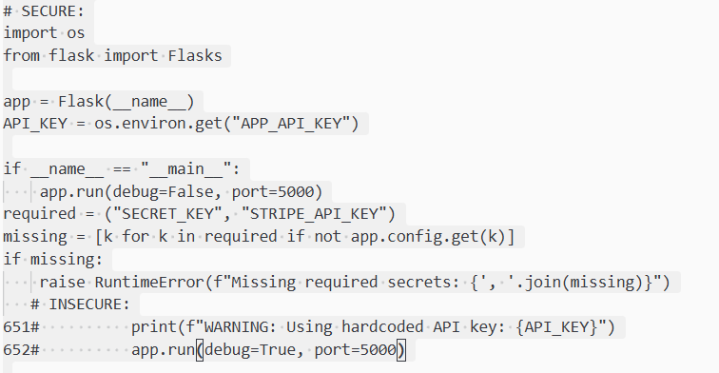

B3: Disabled Original API Code
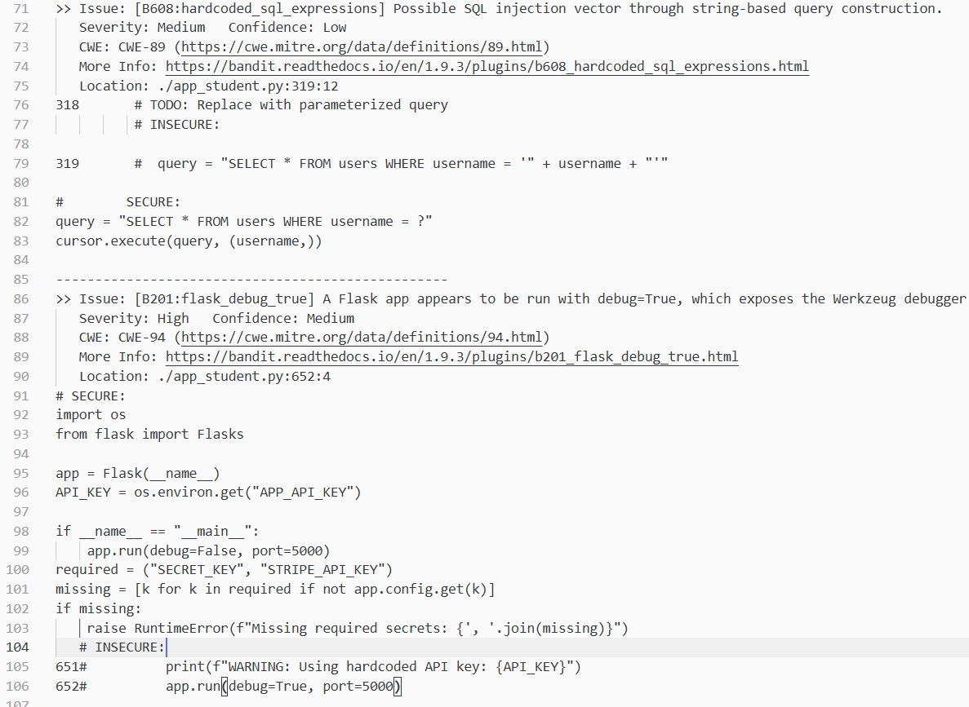

Section C: Test Cases & Execution

C1: Pytest Framework Naming Convention
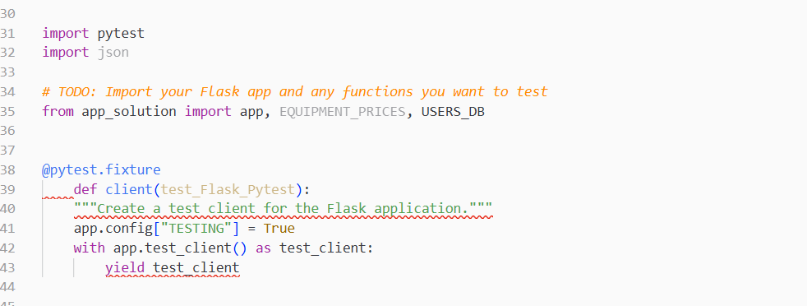

C2: Assert Statements for Outcome Validation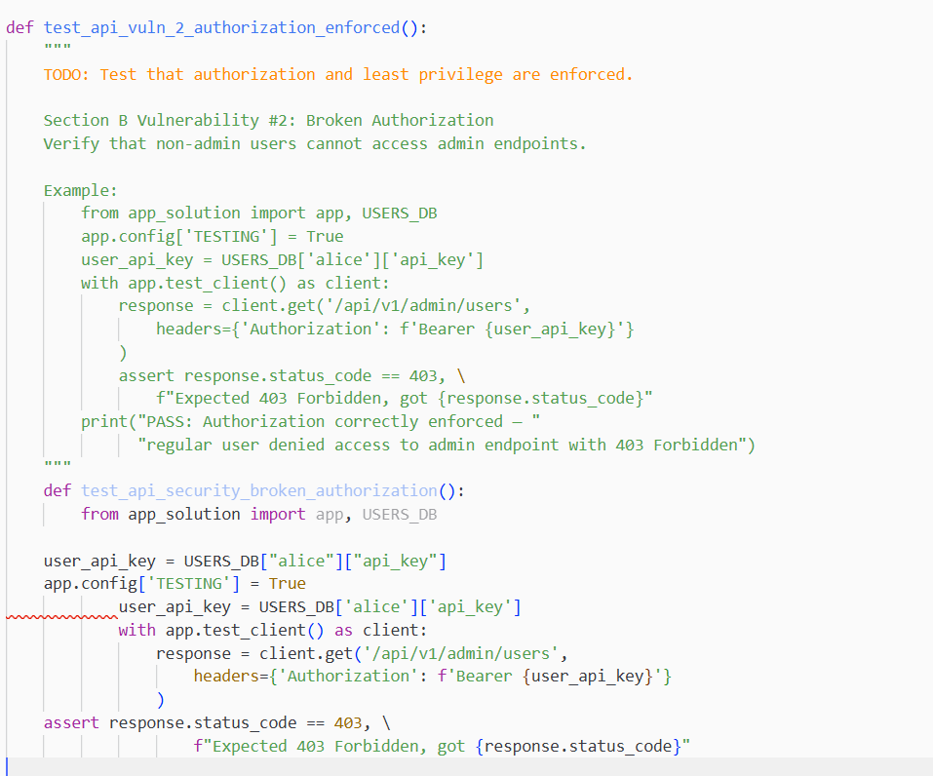

C3: Successful Test Suite Execution
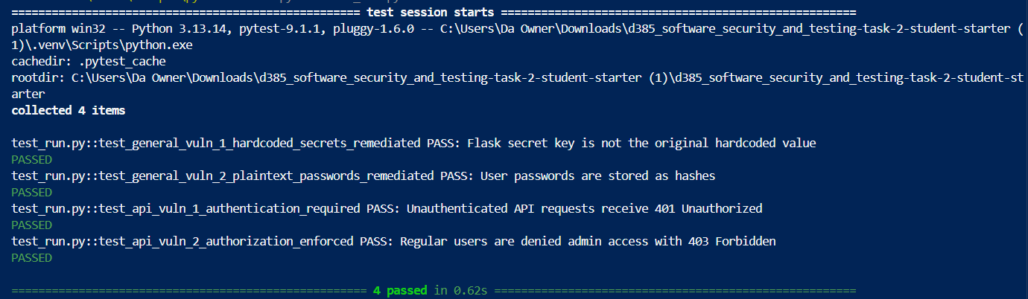

C4: Console Output with Descriptive Log Comments
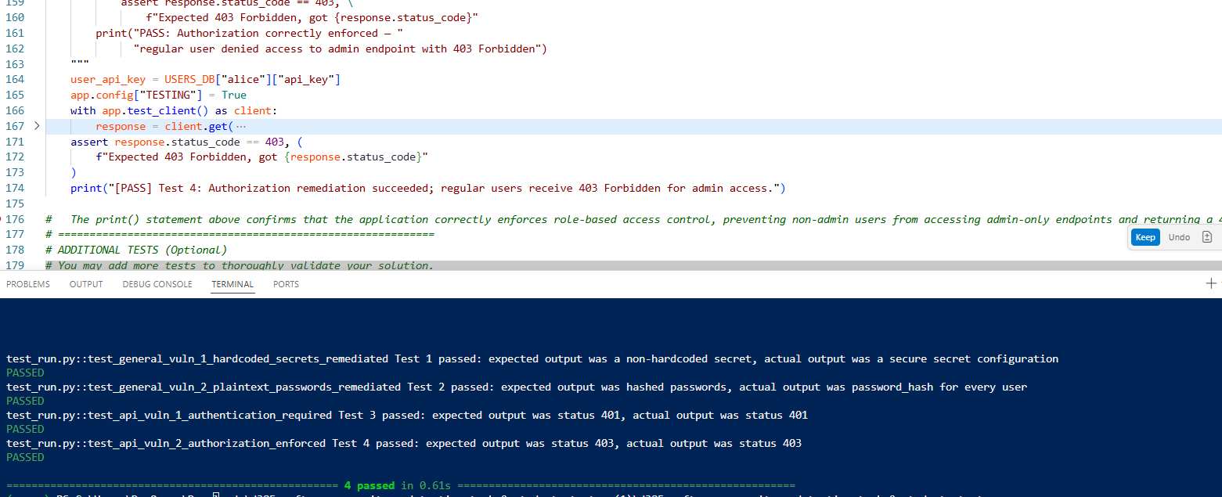

C5: Screenshots of Passed Vulnerability Tests (4 Required)
- General Vulnerability Test 1 Pass (Hardcoded Flask Secret Key):

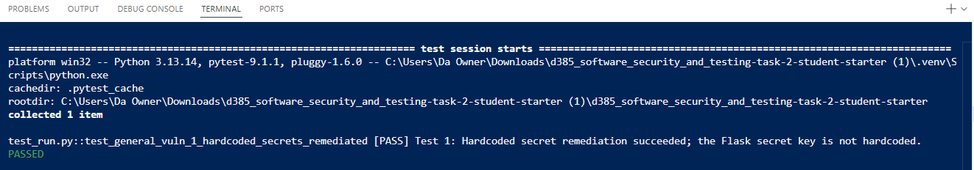
- General Vulnerability Test 2 Pass (Potential SQL Injection):

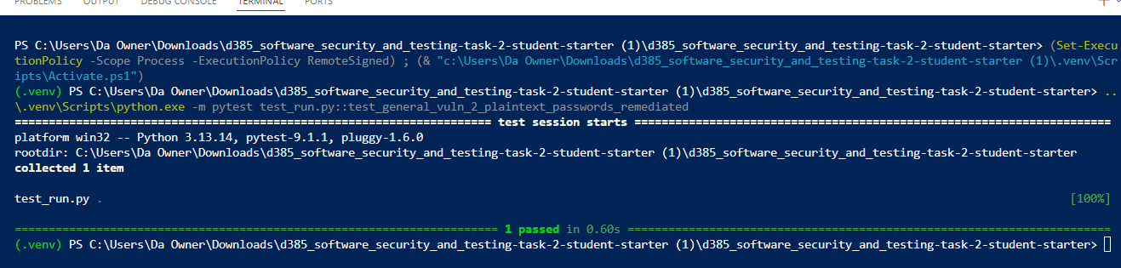

- API Vulnerability Test 1 Pass (API Key Authentication Check):

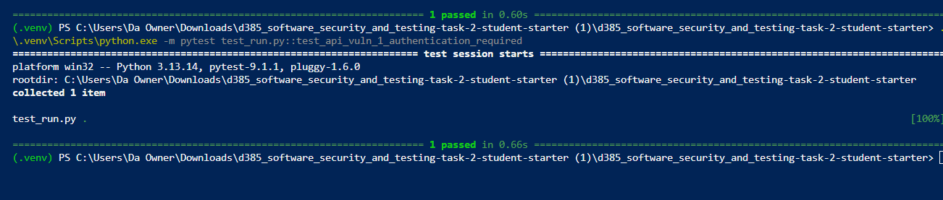

- API Vulnerability Test 2 Pass (Data Minimization / Least Privilege Check):

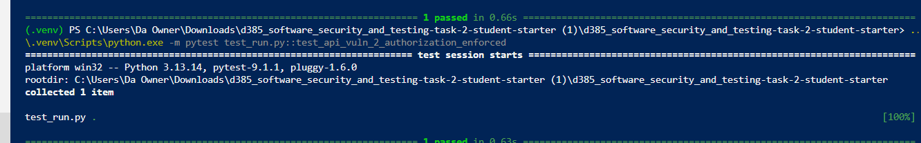

Section D: Written Security Mitigation Report

  - D1: Mitigation Strategies Implemented
- Mitigation Strategy 1 (Environment Variable Credentials & Secret Isolation): To remediate hardcoded application secrets, sensitive cryptographic keys and API tokens were removed from source code files and isolated in environment variables accessed via app.secret_key = os.environ.get("FLASK_SECRET_KEY"). This ensures that sensitive credentials are not exposed in plaintext within static code repositories, preventing secret exposure vulnerabilities.

- Mitigation Strategy 2 (Parameterized SQL Fields & Debugger Disablement): The username is supplied separately from the SQL command, so it is treated as data rather than executable SQL. This prevents malicious input from changing the query structure. The Werkzeug debugger can expose detailed stack traces, file paths, source-code information, configuration values, and environment data when an application error occurs. This was fixed so that detailed errors would be recorded only in protected server-side logs, to avoid an attacker from being able obtain credentials, alter or delete data, or cause a server disruption.

  - D2: Input Validation Techniques
- Value Availability & Validation: The application should verify that the equipment name is one of the available options, such as "Bulldozer", "Excavator", or "Crane". This prevents invalid or unexpected equipment values from being processed.

- Numerical Range & Boundary Enforcement: Before processing the rental request, the application should check that days are a whole number and will be within a reasonable range, such as 1 to 365. This prevents inputs like "abc", -10, or an extremely large number.

D3: Exception Handling Improvements
- Suppression of Server Stack Traces: The application should return a general message such as "An internal error occurred" instead of exposing str(e). Hiding these details prevents attackers from learning how the application is built and reduces the risk of further attacks.

- Detailed Logging in Secure Environments: Detailed exception information should be written to protected server-side logs for developers and administrators. The client should receive only generic error response. This approach improves reliability because developers still have the technical information needed to diagnose and fix failures

D4: Encryption Method for Application & API Traffic
- Transport Layer Security (TLS / HTTPS): TLS/HTTPS secures traffic between the client and Flask API. It encrypts usernames, passwords, API keys, requests, and responses while they travel across the network. This helps prevent attackers from intercepting or modifying sensitive data. The API should use HTTPS with a valid TLS certificate instead of unencrypted HTTP.

